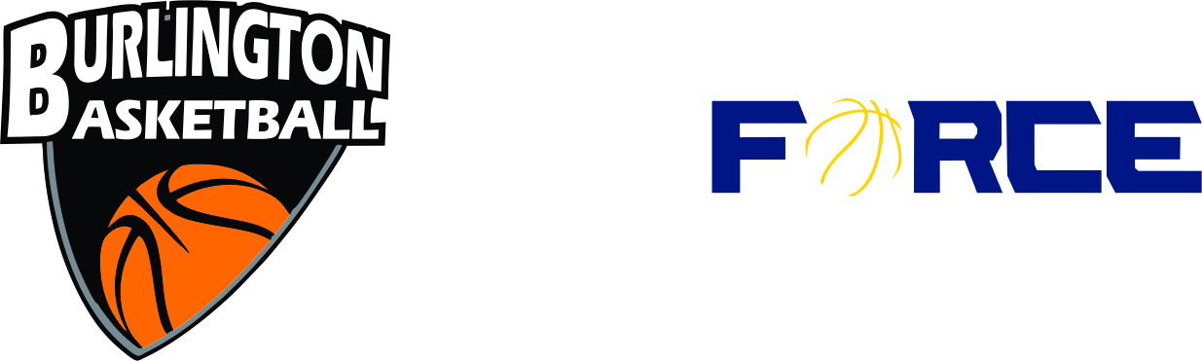

**Burlington Basketball Club**

**Coaching Application Form**

2022/2023

|  |  |  |  |  |
| --- | --- | --- | --- | --- |
| **Name:** | **Home Phone:** | | **Mobile Phone:** | |
| **Address:** | | | **Work Phone:** | |
| **Occupation:** | | | **Work Location:** | |
| **Email:** | **Police Records Check –**note the dating of your most recent check | | Please enclose **Record Check**  at time of submission | |
| **NCCP Coaching Certifications –** Please note dates and locations of completion | | | **NCCP #** | |
| **Level 1** | | | | |
| **Theory (or intro to Comp A)** | **Technical** | | **Practical** | |
| **Level 2** | | | | |
| **Theory (or intro to Comp B)** | **Technical** | | **Practical** | |
| **Level 3** | | | | |
| **Details:** | | | | |
| **Other** | | | | |
| **Details:** | | | | |
| **If not, are you interested in pursuing the NCCP Certification?** | | | | |
| **Yes/No? Details:** | | | | |
| **Previous Clubs coached with: (please identify if still coaching with the latest club)** | | | | |
|  | | | | |
| **Previous Playing Experience –** please include all relevant details of prior basketball playing experience | | | | |
| **Details:** | | | | |
| **Coaching Philosophy – please describe your philosophy as it relates to:** | | | | |
| **Winning:** | | | | |
| **Sportsmanship:** | | | | |
| **Discipline:** | | | | |
| **What do you enjoy most about coaching?:** | | | | |
| **Do you have any children interested in playing in within the Burlington Basketball programs?** | **Child Birth Year:**  **Prior Basketball Experience:** | | **Child Birth Year:**  **Prior Basketball Experience:** | |
| **Development Program Interested in Coaching?** | | | | |
| **Steve Nash Youth Basketball:** | | **Once A Week NCAA:** | **Twice A Week WNBA/NBA:** | |
| **Boys:** | | **Girls:** | **Would you consider an Assistant Coaching Role?** | |
| **Comments:** | | | | |
| **REP Program Team Interested To Coach?** | | | | |
| **Boys / Division(age):** | | **Girls / Division(age):** | **Would you consider an Assistant Coaching Role?** | |
| **Other interests/attributes outside of basketball that would enhance your coaching experience?** | | | | |
| **Other coaching commitments? –** do you have other coaching commitments in basketball season (Sept to May) that need to be considered? If so, please provide some suggestions on how the commitments would be balanced. | | | | |
| **References – Please provide two references from the club of previous coaching positions held** | | | | |
| **Name:** | | **Relationship:** | | **Phone #:** |
| **Name:** | | **Relationship:** | | **Phone #:** |
| **Please return by email to:** | | **operations@burlingtonbasketball.ca** | |  |
|  | |
| **Or mail back to Burlington Basketball:** | | **2186 Mountain Grove Ave**  **PO BOX 175**  **Burlington ON L7P 4X4** | |

**COACHES CODE OF CONDUCT**

A basketball coach is a teacher, a leader or an instructor to train, educate or motivate athletes and can have tremendous influence on the social, emotional, and physical development of young athlete of any age. Every athlete’s experience on the basketball court, whether positive or negative may remain part of them for the rest of their life. Burlington Basketball (BB) ensures that the coach/athlete relationship is of the utmost success with emphasis on the athletes and to maximized young athletes experience in the game of basketball. All Burlington Basketball coaches must display the utmost ethical and moral qualities at the same time being a powerful role model, mentor and a teacher to each and every athlete he/she coaches.

Coaches of Burlington Basketball should be made aware of their responsibilities to the team, the players, the club and the community as a whole and as such should conduct themselves in the manner that is appropriate and promote education around our young players. Coaches are anyone who participates as a teacher, leader or instructor to train, educate or motivate athletes to compete in an athletic activity. That being said, BB coaches’ primary goal is to educate and develop our young athletes.

All BB Coaches should adhere to the following:

* + Prepare to be good leaders, a positive influence and role model to all our young athletes.
  + Communication in a positive and rational manner.
  + Show respect and recognize the differences in each young athlete.
  + Demonstrate respect for all individuals; the players, other coaches, the officials and the game of basketball in general.
  + Be committed to fair play and reward effort where necessary.
  + BB coaches will promote discipline and good sportsmanship.
  + The use of proper language on and off the court should be expected at all times.
  + Unnecessary criticism and negative behavior around our young athletes will not be tolerated by BB.
  + Unnecessary criticism and negative comments towards other clubs, coaches or players will not be tolerated by BB.
  + Unwarranted pressure should not be placed on young athletes at the BB; instead coaches should encourage our young athletes to focus on team participation.
  + BB coaches will be approachable to athletes, parents and promote athletes to comment in a way that is not based on fear or intimidation.
  + BB Coaches should promote the primary wellbeing, development, health and enjoyment of each athlete and should not base their coaching on any personal desire to win at all times.

**Quality of a Good Coach**

* + - Every coach should develop a coaching philosophy and promote team playing.
    - Have curriculum in place to teach the game of basketball.
    - A good coach should have the ability to know when to make the right age decision and plans for his/her team
    - Coaches should make sure his/her team has the appropriate safe environment where they practice and play.
    - A good coach must inspire and motivate his/her team when needed.
    - Make sure legal, moral and ethical standards are in place.
    - A good coach should be a good communicator and does not lose his/her temper easily.
    - A good coach must be reliable and responsible.
    - A good basketball coach should know the rules of the game of basketball and follow them.
    - A good coach should be adaptable, flexible and modify the basketball game to fit the appropriate age he/she coaches.
    - Should not discriminate, prejudice, nor allow such behaviors on court.
    - A good coach should bear in mind the role they play in our communities and as such should be trustworthy and honest with his/her athletes.
    - A good coach should respect himself, his players, his organization, his staff, and the community.
    - A good coach should have knowledge of first aid, health laws, and the use of safety equipment.
    - A good coach must acknowledge any form of injury of any athlete and carry out the appropriate care and procedures for the athlete.